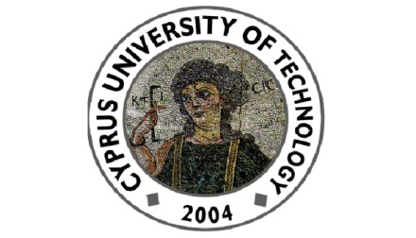

Cyprus University of Technology
Department of Commerce, Finance and Shipping

Seminar Talk
Friday 17th of April 2015
(during the Spring 2015 Conference of the Multinational Finance Society )

“Do Risk-Taking Incentives Induce CEOs to Invest? Evidence from Acquisitions”
by
Prof. Dimitris Petmezas
(University of Surrey - Surrey Business School)

Abstract

This paper examines the effect of risk-taking incentives on acquisition investments. We find that CEOs with risk-taking incentives are more likely to invest in acquisitions. Economically, an inter-quartile range increase in vega translates into an approximately 4.22% enhancement in acquisition investments, consistent with the theory that risk-taking incentives induce CEOs to undertake investments. Importantly, the positive relation between vega and acquisitions is confined only to non-overconfident CEOs subgroup. Further, corporate governance does not generally affect the association between vega and acquisition investments. Finally, vega is positively related to bidder announcement returns.

Department of Commerce, Finance and Shipping
115, Spyrou Araouzou Street, 3606, P.O.Box. 50329, 3603, Lemesos
Tel. 25002489 Fax. 25002637 Email. cfs.seminars@cut.ac.cy

